Readings & Assignments: Week 2

Week 2 Reading
Complete the following reading early in the week:
- Read online lectures

Week 2 Assignments Overview
This course has been designed to build skill each week in a given area, please complete the assignment in the order in which they are present and submit all work at least 2 days before the end of the week for review and critique.
Assignment Summary Week 2
Assignment 1: More Drawing
Assignment 2: Working with Objects
Assignment 3: Pathfinder and Blend Functions
Remember that all Assignment details can be found on the assignment pages located throughout the week. Go to those specific pages for direction on how to complete each individual assignment.

Overview
Last week, we learned about the Illustrator work area and how to generally work with Illustrator files. We also explored using color, selecting objects, and used a few basic drawing techniques.

In Week 2 of this course, we will discover even more techniques for drawing. We will also learn methods for organizing and modifying multiple objects in an Illustrator image.
Let’s continue with our introduction to Illustrator!

More Drawing

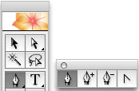
Pen Tool
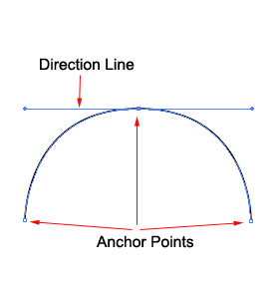
The Pen Tool is the most powerful of your Illustrator drawing tools. No other tool allows you the level of precision and editing control as the Pen Tool. However, the Pen Tool takes practice to master. The following tips will allow you to understand the Pen Tool and begin to master this powerful drawing tool.
The Pen Tool is located on the Toolbox. Click and hold down the mouse button to expand the Pen Tool to see the Add Anchor Point, Delete Anchor Point, and Convert Anchor Point tools.
The Pen Tool uses “anchor points” and “direction lines” to precisely control the creation and editing of lines and curves. An anchor point will define where each line or each segment of a line starts or ends. The direction lines control the shape of the curve.
Drawing Straight Lines
Drawing straight lines is simple. Click once to place an anchor point where you would like the line to start and click again to place an anchor point where you would like the line to end. The line is automatically placed between the two anchor points.
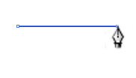
The straight line may be edited by selecting and moving the anchor points with the Direct Selection Tool. (Note: toggle between the Direct Selection Tool and the Pen Tool by holding down the Command key on a Macintosh and the Control key on a PC).
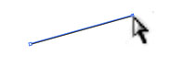
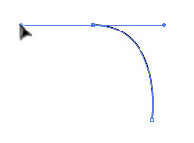
Drawing Curved Lines
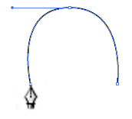
Drawing curves is only slightly more complicated. It requires using both anchor points and direction lines. Click to place an anchor point where you would like the curved line to begin. Click to place the second anchor point and, while still holding down the mouse key, drag to create a direction line that controls the curve.
Click a third line to see how the direction line continues to control the curve.

The curve may be edited by using the Direct Selection Tool to move the anchor points or adjust the direction lines to change the curve.
Adding / Converting / Deleting Anchor Points
Anchor points may be added to an existing line or curve by using the Add Anchor Point Tool. Select the tool from the Toolbox and click anywhere on an existing line to add an anchor point. The anchor point may be moved by first selecting it with the Direct Selection Tool and then dragging the mouse.
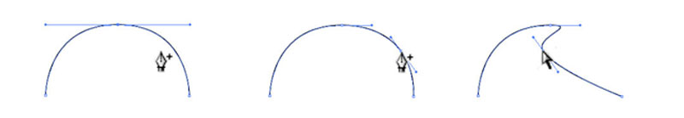
An existing anchor point can be converted to an anchor point with direction lines by using the Convert Anchor Point Tool. Select the Convert Anchor Point Tool and click and, while holding down the mouse key, drag to use direction lines to control the curve.
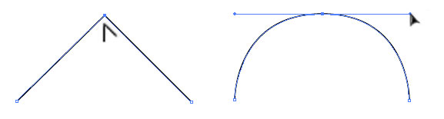
An existing anchor point with or without direction lines may be deleted by using the Subtract Anchor Point Tool. Select the Subtract Anchor Point Tool and click on any anchor point to remove it from a line or curve. Any direction lines will also be deleted.
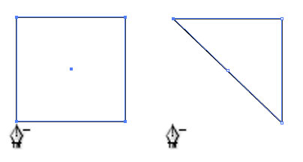
An easy way to draw curves with precise control is to draw the anchor points first, and then use the Convert Anchor Point Tool to add the curves.
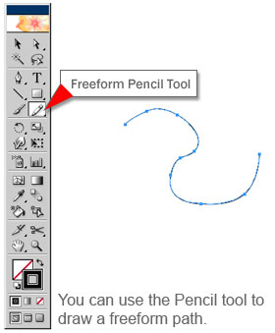
Pencil Tool
You can additionally draw freeform paths with the Pencil Tool located directly below the Shape Tools in the Toolbox. The Pencil Tool lets you draw open and closed paths as if you were drawing with a pencil on paper. It is most useful for fast sketching or creating a hand-drawn look. Once you draw a path, you can immediately change it if needed. Anchor points are placed as you draw with the Pencil Tool; you do not determine where they are positioned. However, you can adjust them once the path is complete. The number of anchor points created is determined by the length and complexity of the path and by tolerance settings in the Pencil Tool Preferences dialog box. These settings control how sensitive the Pencil Tool is to the movement of your mouse or graphics-tablet stylus.
To draw a freeform path with the Pencil Tool:
- Select the Pencil Tool.
- Position the Tool where you want the path to begin, and drag to draw a path. The Pencil Tool displays a small x to indicate it is drawing a freeform path.
- As you drag, a dotted line follows the pointer. Anchor points appear at both ends of the path and at various points along it. The path takes on the current paint attributes, and the path remains selected by default.
- To continue the existing freeform path, make sure the path is selected, and then position the pencil tip on an endpoint of the path and drag. (You can tell you're close enough to the endpoint when the small x disappears.)
- To close the path into a shape, hold down Alt (Windows) or Option (Mac OS). The Pencil Tool displays a small o to indicate you're creating a closed path. When the path is the size and shape you want, release the mouse button (but not the Alt or Option key) to connect the starting and ending points of the path. After the path closes, release the Alt or Option key.

Gradients
Gradients allow you to apply a graduated blend of colors to an object just as you would apply a solid color.
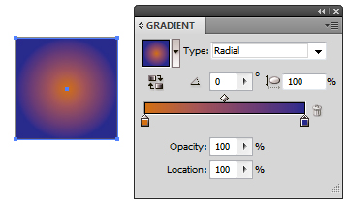
Gradient Panel
The Gradient panel (Window > Gradient) allows you to apply, create, and modify gradients. Selecting Show Options from the pop-up menu in the upper-right hand corner of the panel will display all of the available options in the panel when working with gradients. The Gradient Fill box in the upper-left hand corner of the panel displays the current gradient colors and type. Clicking this box will fill a selected object with the current gradient.
Applying Gradients
Preset gradients can be selected from the Swatches panel (Window > Swatches). Clicking on a gradient in the Swatches panel will apply that gradient to a selected object. Illustrator has a variety of other Gradient Presets that you can choose from. Click the Window menu and choose Swatch Libraries, Gradients. This will open a separate panel of gradients. Once you click on a gradient from that panel to apply to an object, it will be added to the regular Swatch Panel.
Once you have filled an object with a gradient, you can use the Gradient Tool to modify the appearance of the gradient by defining a new fill direction. The Gradient Tool allows you to specify the starting and ending points for the gradient, as well as change the colors that flow within the gradient.:
- Begin by filling a selected object or objects with a gradient. To apply a gradient across multiple objects, fill each of those objects with a gradient.
- With the object or objects selected, select the Gradient Tool from the Toolbox.
- Position the pointer where you want to start the gradient, and then click and drag across the object(s) in the direction you want the gradient to be filled.
- Finally, release the mouse button where you want to end the gradient.
The new length and direction for the gradient will then be applied across your selected object or objects.

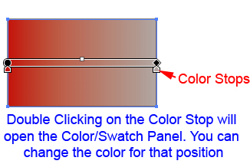
Creating Gradients
You can create your own gradient by using the Gradient Tool.

Begin by filling a selected object or objects with a gradient. With the object or objects selected, select the Gradient Tool from the Toolbox.

Position the pointer where you want to start the gradient, and then click and drag across the object(s) in the direction you want the gradient to be filled.
You will notice that a line now appears where you drew the gradient. The starting point will have a rounded circle and the ending point is a square. Bring your mouse onto top of the line and it will expand.

You will see Color Stops below the expanded line. This controls where the color is located in the gradient. To change the color, double click on the Color Stop. This will open a panel to choose a color from the Color Panel or Swatches panel. If you want to add another color to your gradient, just click right below the expanded line. It will add a Color Stop. To change that color, just double-click on the Color Stop as you did before. If you accidentally added a Color Stop that you do not want, drag that Color Stop from the bottom of the expanded line and release.
In versions prior to CS4, the editing of the gradient will differ.
For a tutorial on creating your own custom gradients, visit: Illustrator CS4 or later: http://tv.adobe.com/#vi+f1586v1019
Illustrator CS3 or earlier: http://www.adobe.com/designcenter/illustrator/articles/ill11kbgradient.html

Working with Objects

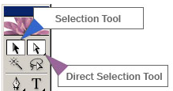
Arranging Objects
Another strength of Adobe Illustrator is its ability to allow you to directly select objects and reposition or otherwise modify them. To select an object, choose the Selection Tool and click on that object. To select multiple objects, click and drag a selection marquee around those objects. To add or remove an object from the selection, hold down the Shift key and click on the objects you wish to add or remove.

With objects selected in the work area, you can then move those objects by dragging them to a new location. In addition, you can move a selected object using the Arrow keys. Simply press the arrow key for the direction in which you want to move the object. The distance the object moves each time you press an arrow key is determined by the value specified in the Keyboard Increment text box in the General Preferences dialog box. Holding down Shift while using the arrow keys will move the object ten times the value specified by the Keyboard Increment preference.

Duplicating Objects
You can duplicate objects in Illustrator by selecting those objects and dragging them to a new location while holding down the Alt (Windows) or Option (Mac) key. When you release your mouse button, copies of the objects will be placed in the new location.
You can also use the Edit > Copy and Edit > Paste commands to copy objects onto the clipboard and paste them into an Illustrator document just as you would in any other program.
Transforming Objects
You can transform basic objects into newly defined shapes moving by Rotating, Reflecting, Scaling, and Shearing those objects.
These transformations can be achieved using the following tools in the Toolbox:
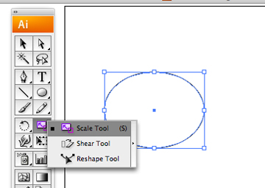
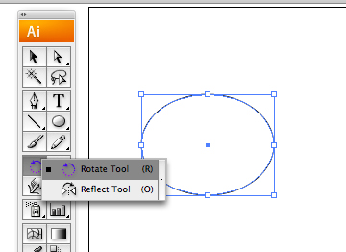
Or you can achieve the same effects using the commands under the Object >Transform menu:

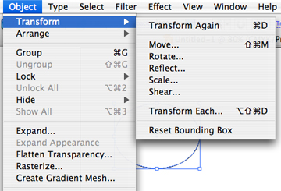

In both methods you can define exact measurements for the transformation using a dialog box. You can repeat a transformation by using the Transform Again command. You can also apply certain transformations by dragging the bounding box of a selected object or by using the Transform panel (Window>Transform) and changing the appropriate measurements.

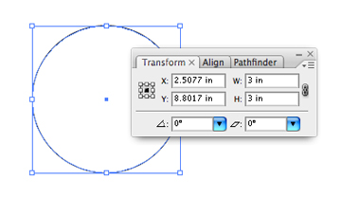
Below are two examples of objects that have been transformed using the rotating, shearing, reflecting and scaling tools:
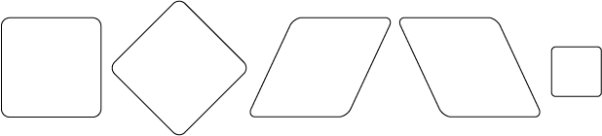

You are encouraged to experiment with these tools to observe the various effects that can be produced.

Stacking Objects
In addition to the horizontal and vertical location of an object on a page, Illustrator also stacks successively drawn objects on top of one another. Beginning with the first object drawn, each successive object is drawn on top of the next. This determines how different objects will display when they overlap one another. You can change the stacking order of selected objects in your using the Object > Arrange commands:
- Object > Arrange > Bring to Front - Moves an object to the top position in the work area.
- Object > Arrange > Send to Back - Moves an object to the bottom position in the work area.
- Object > Arrange > Bring Forward - Moves an object one step forward in the stacking order.
- Object > Arrange > Send Backward - Moves an object one step backward in the stacking order.
When objects are duplicated using the copy/paste method, a copy of the original object will be placed in the center of the work area at the top of the stacking order.

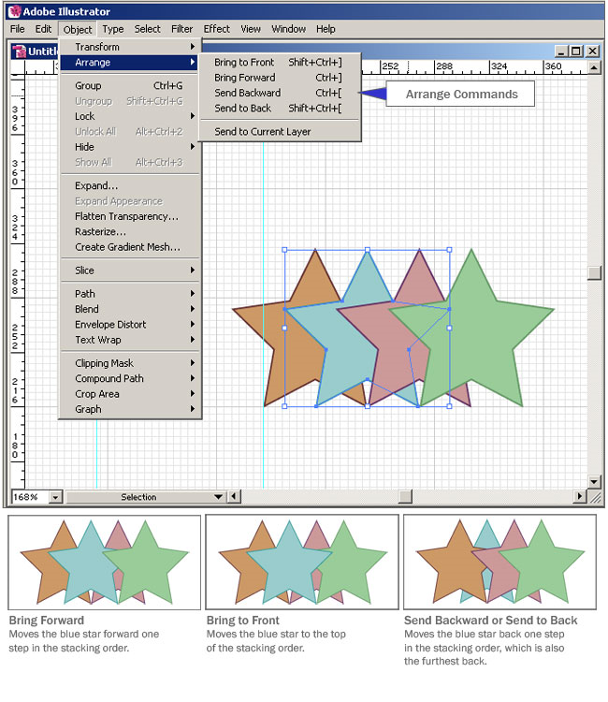

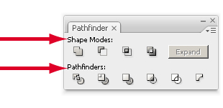
Pathfinder Panel
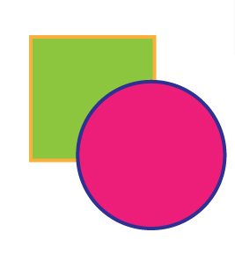
The Pathfinder panel lets you combine multiple objects into new shapes, and is split up into 2 rows. The first row contains the SHAPE MODES and the second row contains the PATHFINDER MODES. NOTE: You need to have more than one object drawn and overlapping to use these panel options. Pay attention to the stacking order of the objects before deciding on which pathfinder option you will choose.
Here are two overlapping shapes, a circle and square, which are filled and stroked with different colors. We’ll observe the effects of the Pathfinder commands on these shapes.
Shape Modes
1) ADD TO SHAPE AREA - Since the circle is the top most shape, clicking the Add to Shape Area button adds the 2 shapes together to create one shape with the circle’s attributes of a blue stroke and pink fill. Before clicking on the Expand button, the positions of the shapes can still be altered using the Direct Selection Tool. You will still notice individual anchor points for each shape.
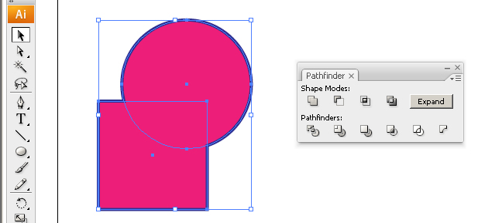
Once the Expand button is pressed, the two shapes merge together and cannot moved independently of one another. Only one set of anchor points is visible for the new composite shape.
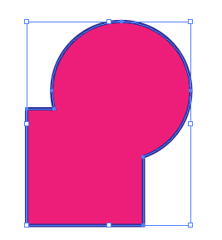
If you know in advance that you will not change the positions of the objects after applying a Pathfinder command, you can hold down the Alt (Window) or Option (Mac) key while clicking a Pathfinder button to automatically apply the Expand command. This holds true for all of the Pathfinder Shape modes.
2) SUBTRACT FROM SHAPE AREA - This option subtracts the topmost object from the bottom object but keeps the bottom object’s attributes (in this case the bottom object is the green square with an orange stroke). It is important to keep track of which objects are in front and which are behind in order to get the effect that you want out of the pathfinder panel, especially when choosing this option.
Before Expand:
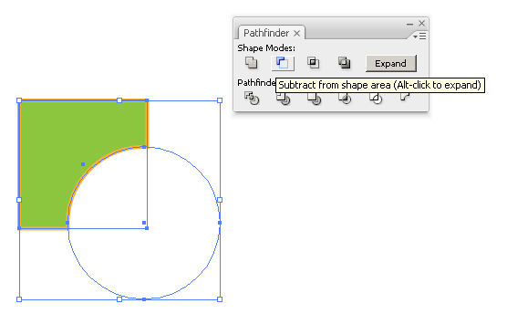
After Expand:
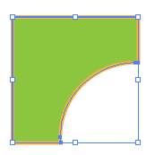

3) INTERSECT SHAPE AREAS - This option keeps the shape that is created by the 2 intersecting shapes. This option takes the attributes from the topmost shape. In this case, since the circle is the top most shape the attributes in which the final shape takes are a pink fill and blue stroke.
Before Expand:
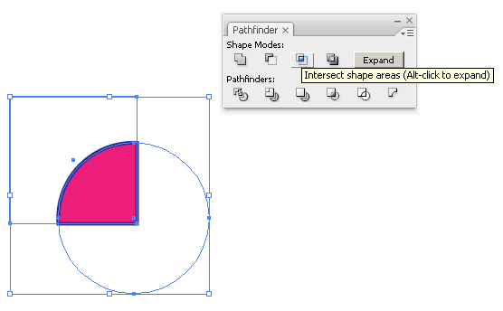
After Expand:
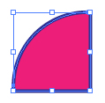
4) EXCLUDE OVERLAPPING SHAPE AREAS - This option excludes the intersected areas and takes on the topmost object’s attributes.
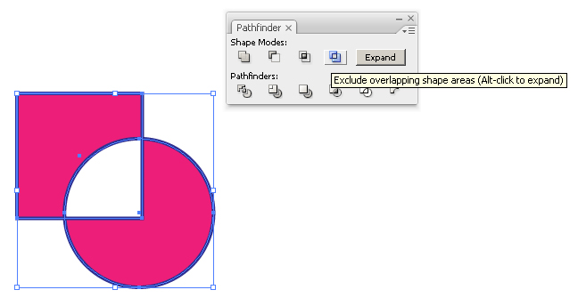

Pathfinder Modes
5) DIVIDE - This option separates the overlapped shapes. One can then fill each shape individually.
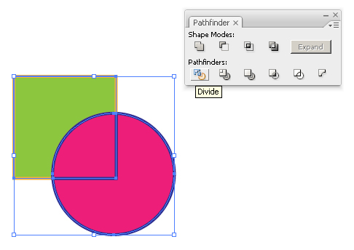
In this example, the middle shape has been selected and given a new fill and stroke.


6) TRIM - In this pathfinder option all overlapping areas are removed. In other words, the top object “trims” away the bottom shape where the two objects overlap. This also gives you separate shapes.
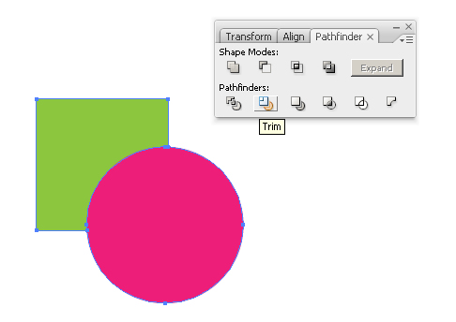
In this example, the trimmed square has been given a new fill and stroke. Again, it is crucial that you remember which object is in front and which is in back in the stacking order especially when you have complicated drawings with several layers.


6) MERGE - This option will allow any objects WITH THE SAME FILL to be merged into on object.
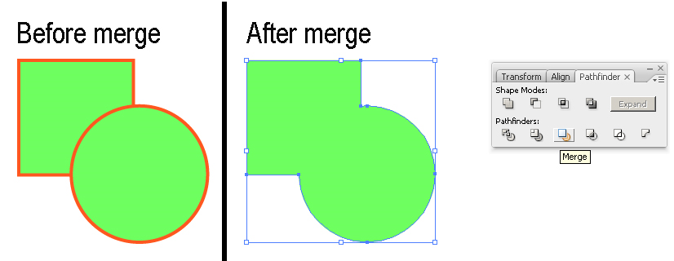
7) CROP - Anything that falls outside the topmost object will be removed. This option trims everything inside the topmost object. This option is good for selecting a small part of a large illustration!
In this example, several objects were created: a star, polygon and circle and square. Then a rectangle was placed on top of ALL of those objects.
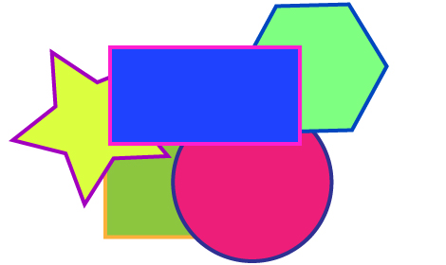
After clicking the Crop button everything INSIDE the rectangle is kept and the other areas are discarded.
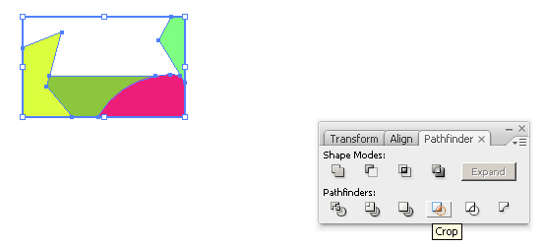

8) OUTLINE - This option divides the shapes into individual paths.
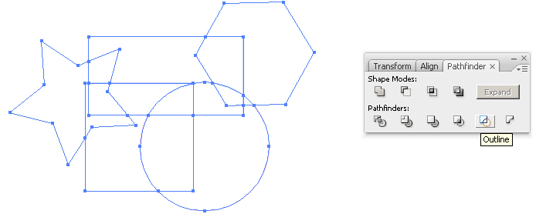
Notice how an individual section of the star can now be selected.
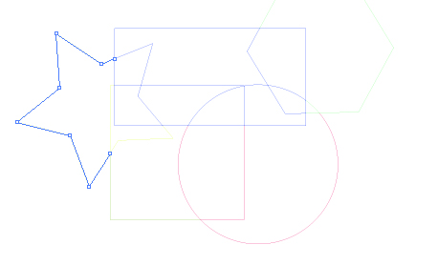
9) MINUS BACK - This is similar to the Subtract From shape mode but this option subtracts the back most object out of the front object.
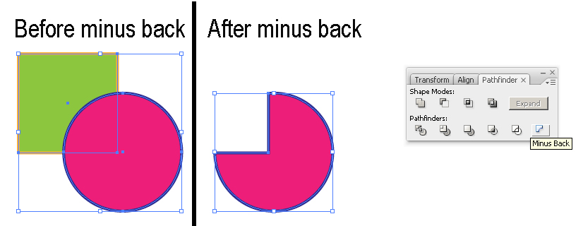
Fun Tutorial: This tutorial shows you how to create PacMan using the Pathfinder panel. Open the following pdf and try it out for yourself. Pathfinder Tutorial
Blend Function
In addition to using the Pathfinder Panel to combine objects into new shapes, you can also use the Blend function to create and evenly distribute a series of graduated forms between two shapes.
Creating Basic Object Blends
Begin by selecting two objects you wish to blend together. Then select the Object > Blend > Make command. This changes the color and shape gradually from one object to another. The Keyboard shortcut for this command is ALT/OPTION + CTRL/CMD + B.

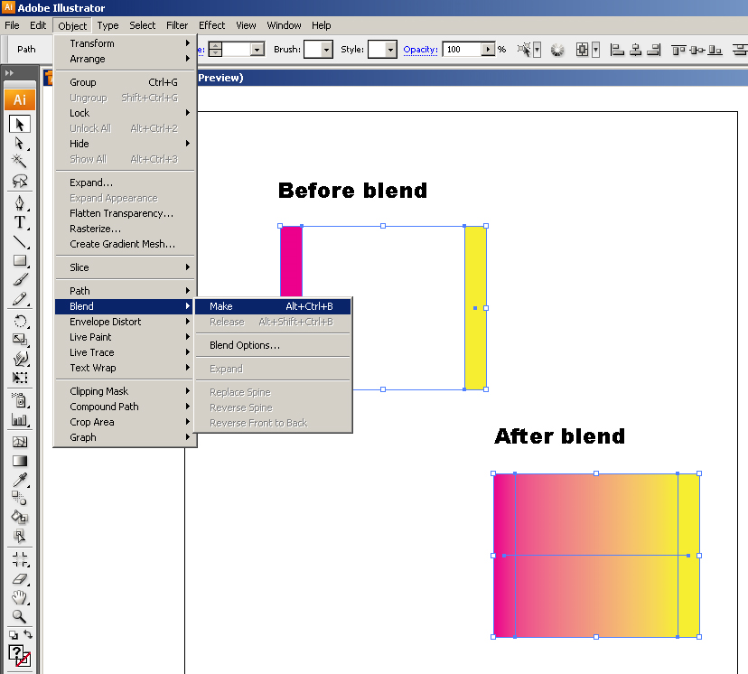
Another way to create a blend is to use the Blend Tool in the Tools panel. With two objects selected, click on one anchor point on the first object with the Blend Tool and then click on another anchor point on the second object. The objects will blend from the starting anchor point to the ending anchor point.
You can also set a stroke for each object and have no fill.
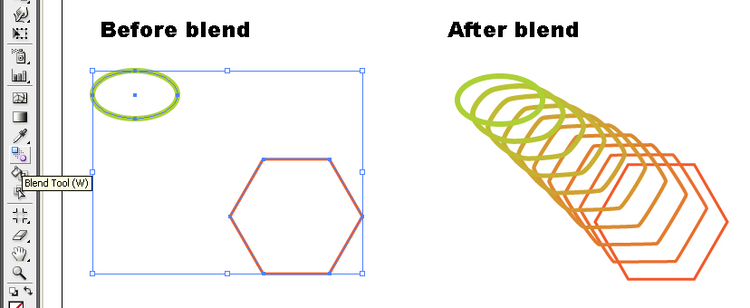
You can always go back and change the color of each object in the blend by first selecting the Direct Selection Tool in the Toolbox and then selecting one of the objects. In this example the oval was changed to red and the polygon to pink.
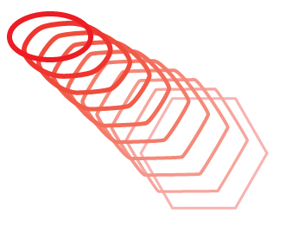

Blend Options
Object blends can be changed by selecting the Object > Blend > Blend Options command.
For example, altering the Spacing option to Specified Steps and changing the value can modify the number of steps in a blend.
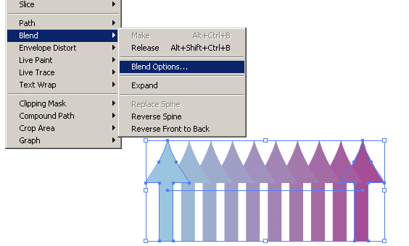
Here, the specified steps in the selected blend have been changed from 8 to 3. Checking the Preview option allows you to preview your changes before clicking OK.

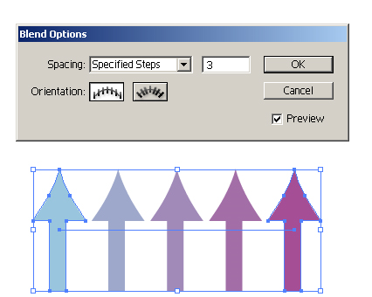
The next time a new blend is created, it takes on the Blend Options that were last specified.

Keyboard Shortcuts
Keyboard shortcuts allow you to quickly execute commands or select tools within Adobe Illustrator. Each week we will present you with a series of keyboard shortcuts that relate to the week’s material. These shortcuts will allow you to more efficiently complete actions in Illustrator, and over time, should become part of your everyday workflow.
When a choice of CTRL/CMD is given, this means that Windows user should hold down the Control key while Mac users should hold down the Command or Apple key. When a choice of ALT/OPTION is given, this means that Windows user should hold down the Alt key while Mac users should hold down the Option key.
Tools
Select Pen Tool – Press P
Select Add Anchor Point Tool – Press +
Select Subtract Anchor Point Tool – Press -
Select Convert Anchor Point Tool – Press SHIFT + C
Select Pencil Tool – Press N
Select Rotate Tool – Press R
Select Reflect Tool – Press O
Select Scale Tool – Press S
Select Free Transform Tool – Press E
Select Blend Tool – Press W
Select Gradient Tool – Press G
Working with Objects
Cut Current Selection to Clipboard – CTRL/CMD + X
Copy Current Selection to Clipboard – CTRL/CMD + C
Paste Clipboard contents into document – CTRL/CMD + V
Move Copy of object – Hold ALT/OPTION and drag object
Object > Transform > Transform Again - CTRL/CMD + D
Object > Transform > Move – SHIFT + CTRL/CMD + M
Object > Arrange > Bring to Front – SHIFT + CTRL/CMD + ]
Object > Arrange > Bring Forward – CTRL/CMD + ]
Object > Arrange > Send Backward – CTRL/CMD + [
Object > Arrange > Send to Back – SHIFT + CTRL/CMD + [
Object > Blend > Make – ALT/OPTION + CTRL/CMD + B
Object > Blend > Release – ALT/OPTION + SHIFT + CTRL/CMD + B

Assignment 1: More Drawing
In this exercise, you will practice using the Pen tool to create irregular shapes with both straight and curved edges.
Complete the following steps:
- Download and unzip the template. Two versions of the template have been included in this zip file. Please use the file that more closely matches the version of software that you are using. *Note to Mac users: If the file won't open correctly, please remove the file extension and manually rename it with ".ai" following the filename.
- Set the Fill Color to White, the Stroke Color to Black, and the Stroke Weight to 1pt.
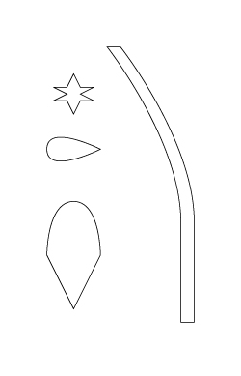
- Next, use the Pen tool to trace the provided shapes. The locations of each shape’s anchor points are indicated on the template. The drawn shapes must align precisely with the template shapes. You are encouraged to place Ruler Guides and use the Grid to assist with alignment.
Save your document in native IL format. Post your assignments in the Discussion Area, if your file size is too large use the Doc Sharing. Use the Discussion Area to review and comment on other students’ work.
Please Note: For those students using Safari you must manually remove the .ps extension when saving the template file.
Assignment 1 Review Criteria
Traced shapes aligned with template
Traced shapes have correct fill and stroke settings
Document saved in proper format

Assignment 2: Working with Objects
In this follow-up exercise, you will use the shapes you created in the previous exercise to create an illustration of a flower. It will involve duplicating, rotating, arranging, and stacking objects to produce the finished result.
Complete the following steps:

- Download and unzip the template. Two versions of the template have been included in this zip file. Please use the file that more closely matches the version of software that you are using. *Note to Mac users: If the file won't open correctly, please remove the file extension and manually rename it with ".ai" following the filename.
- Open your file submission for Week 2 – Assignment 1
- Select all the shapes and copy and paste them into the template document.
- Recreate the provided design using the copied shapes. You will need to duplicate, rotate, arrange and properly stack the copied shapes to accomplish this. Note: the flower petals are rotated 30 degrees from one another and the leaves are each rotated 15 degrees from horizontal. You will also need to create the rectangle to serve as the background for the design.
- Once the layout is complete, color each object to complete the design. You encouraged to experiment with gradient fills to give the design a more realistic look.
- Using the Pencil tool, sign your name in the lower left hand corner of the design.
Save your document in JPEG format. Post your assignments in the Discussion Area, if your file size is too large use the Doc Sharing. Use the Discussion Area to review and comment on other students’ work.
Please Note: For those students using Safari you must manually remove the .ps extension when saving the template file.
Assignment 2 Review Criteria
Layout recreated using copied shapes
Objects colored
Designed signed using the Pencil tool
Document saved in proper format

Assignment 3: Pathfinder and Blend Functions
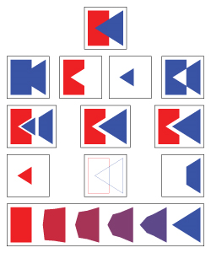
The goal of this exercise to observe the different effects that can be produced through the Pathfinder and Blend functions.
Complete the following steps:
- Download and unzip the template. Two versions of the template have been included in this zip file. Please use the file that more closely matches the version of software that you are using. *Note to Mac users: If the file won't open correctly, please remove the file extension and manually rename it with ".ai" following the filename.
- In the top box, draw two overlapping shapes, each with a different Fill color and no Stroke.
- Copy and paste the overlapping shape arrangement into the next 10 boxes. You are encouraged to place Ruler Guides and use the Grid to assist with alignment.
- In each box, select both shapes and perform the functions listed below.
Important Note: For the box in which you use the Pathfinder Mode 'Merge', you must first make both shapes the SAME fill color before selecting them and applying the merge.
Pathfinder - Shape Mode: Add to shape area | Pathfinder - Shape Mode: Subtract from shape area | Pathfinder - Shape Mode: Intersect shape areas | Pathfinder - Shape Mode: Exclude overlapping shape areas

Pathfinder - Pathfinder Mode: Divide | Pathfinder - Pathfinder Mode: Trim | Pathfinder - Pathfinder Mode: Merge
Pathfinder - Pathfinder Mode: Crop | Pathfinder - Pathfinder Mode: Outline | Pathfinder - Pathfinder Mode: Minus Back
- In the Divide, Trim, and Merge boxes, use the Direct Selection tool to select and slightly move the resulting shapes, allowing each individual piece of the group to be visible.
- Copy and paste your original shapes into the final box, placing one shape near the left edge of the box and the second shape near the right edge. Perform a 4-step Blend between the two shapes.
Save your document in JPEG format. Post your assignments in the Discussion Area, if your file size is too large use the Doc Sharing. Use the Discussion Area to review and comment on other students’ work.
Please Note: For those students using Safari you must manually remove the .ps extension when saving the template file.
Assignment 3 Review Criteria
Two original shapes have different fill colors, no strokes, and are overlapping
10 Pathfinder commands performed on copies of overlapping shapes
Shapes separated in Trim, Divide, and Merge boxes
4-step blend created between original shapes
Document saved in proper format

